COMPUTER ARCHITECTURE
CSA1204-SLOT C

- EXPERIMENT 1 - ADDITION OF TWO NUMBERS

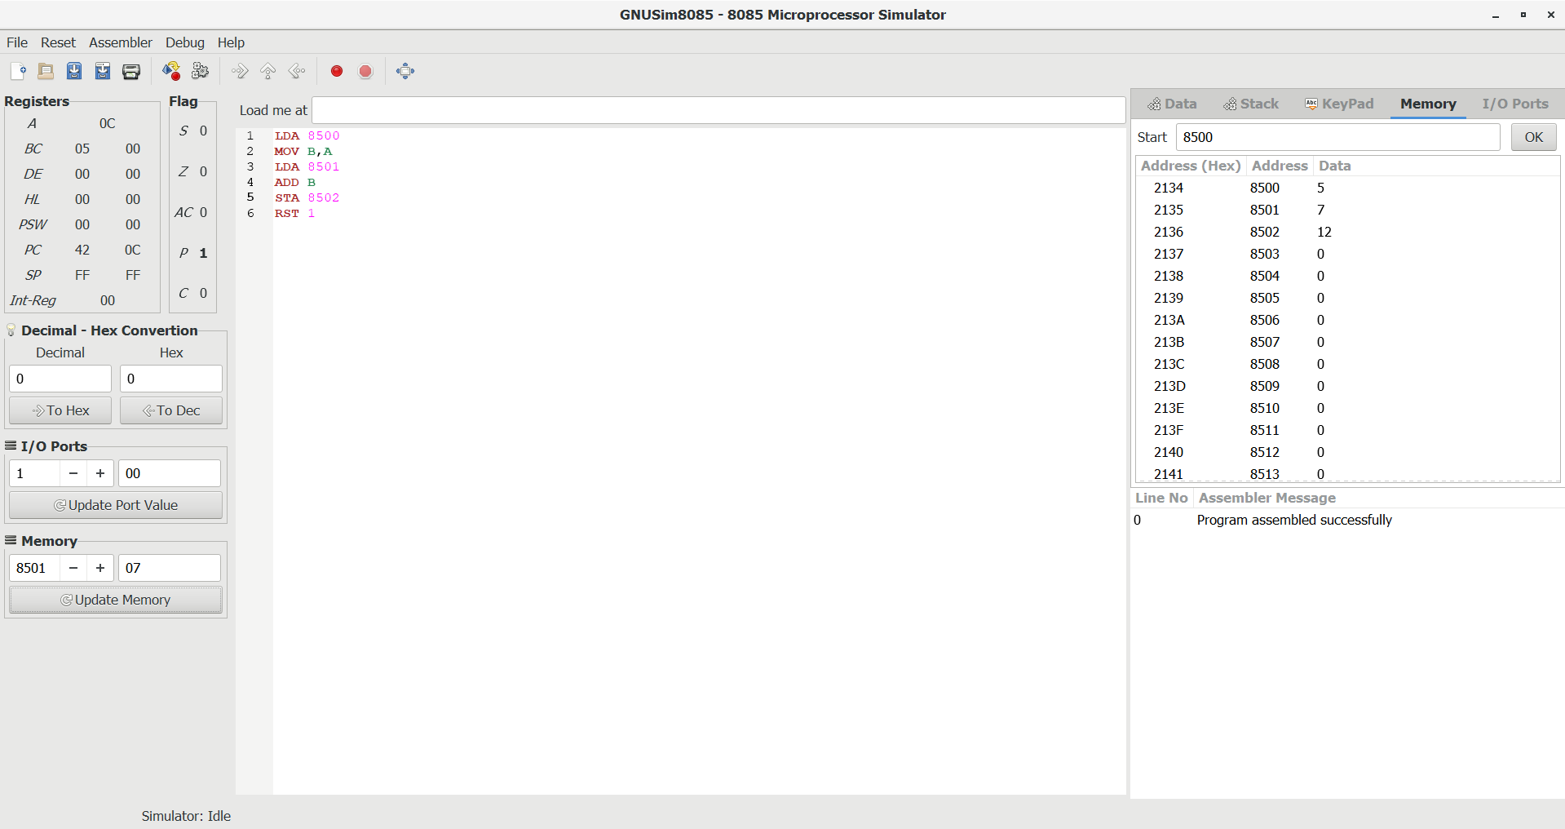
INPUT = 5,7
OUTPUT = 12

EXPERIMENT 2 – SUBRACTION OF TWO NUMBERS

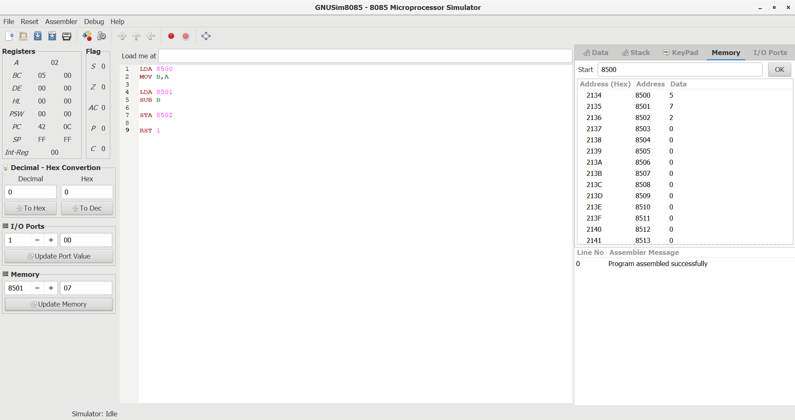
INPUT = 5,7
OUTPUT = 2

EXPERIMENT 3 – ADDITION WITH CARRY

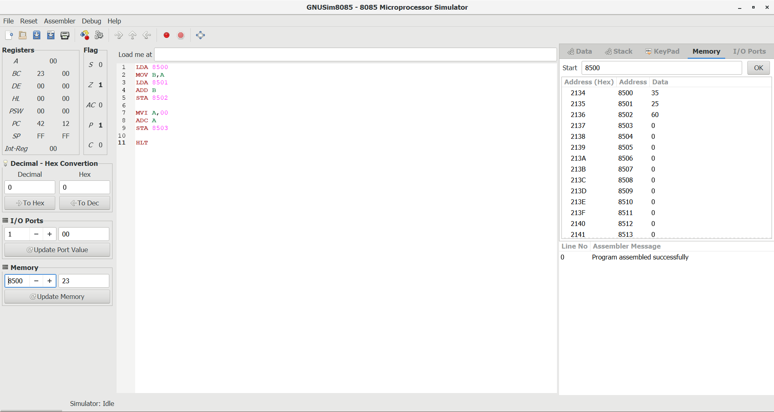
INPUT – 25,35
OUTPUT – 60

EXPERIMENT 4 – SUBRACTION OF TWO NUMBERS WITH BORROW

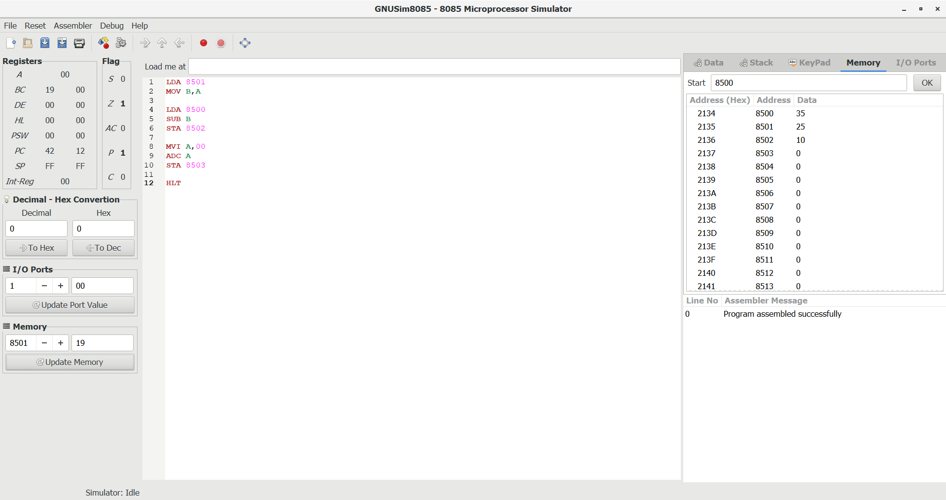
INPUT = 35,25
OUTPUT = 10

EXPERIMENT 5 – MULTIPLICATION OF TWO NUMBERS

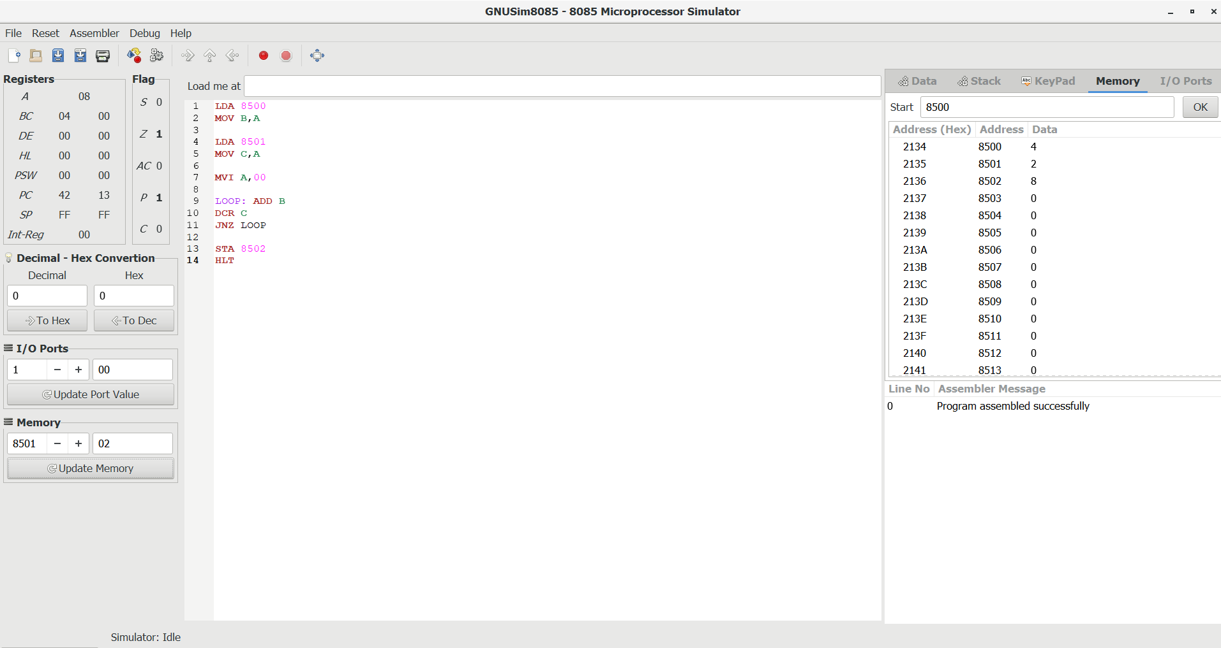
Input – 4,2
output – 8

EXPERIMENT 6- DIVISION OF TWO NUMBERS

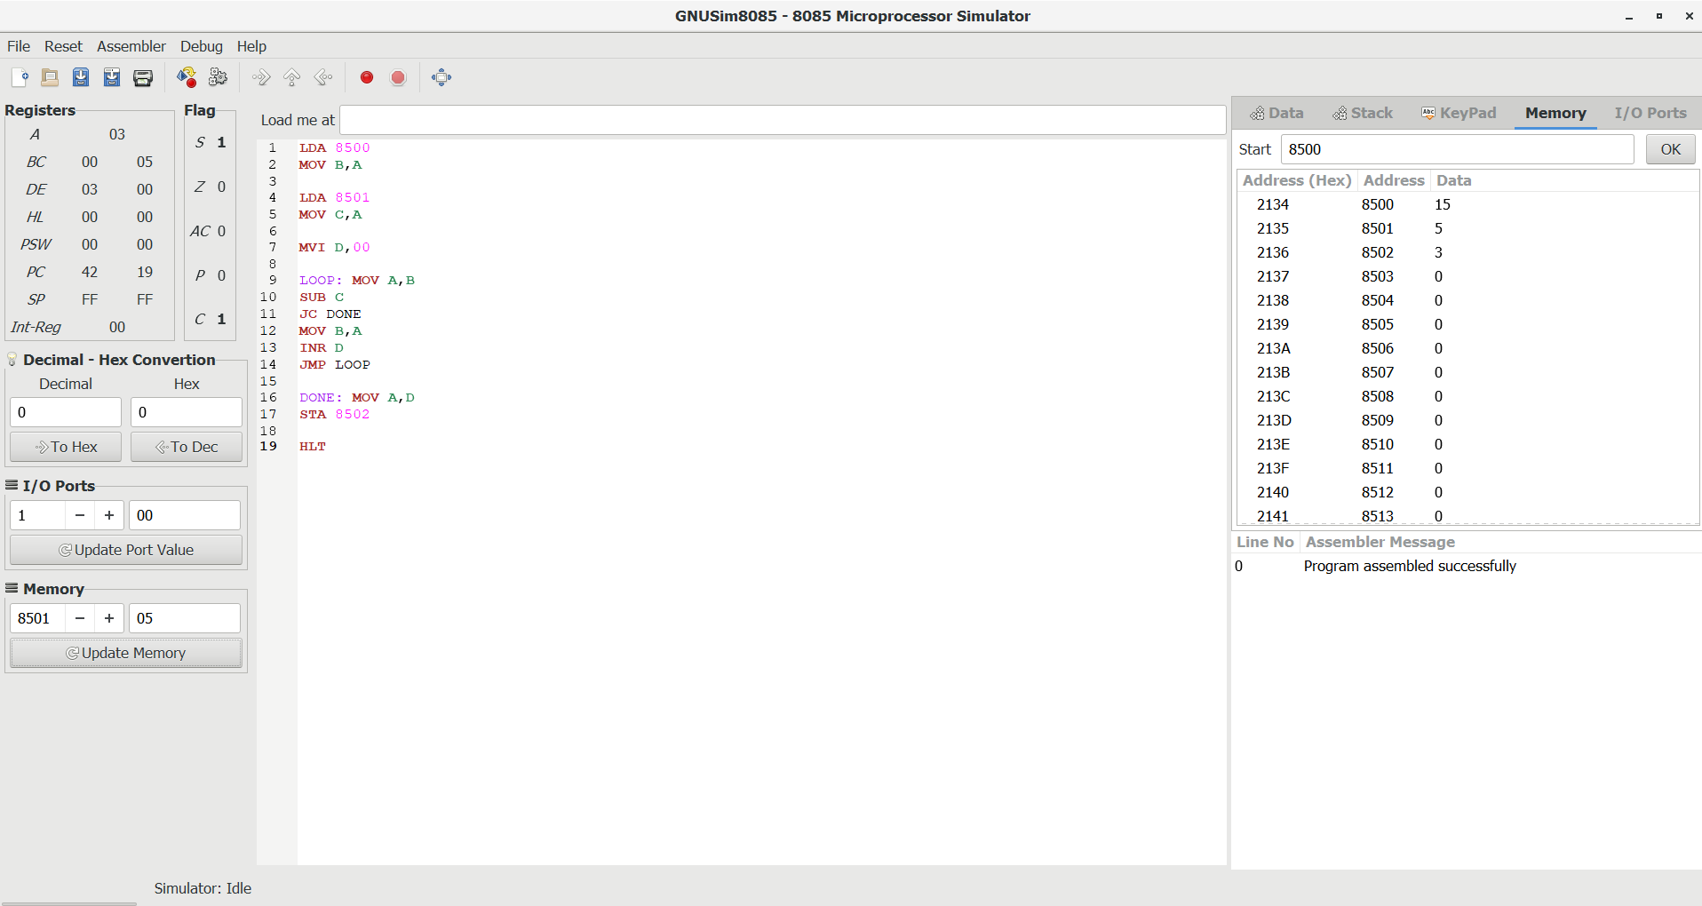
Input -15,5
Output -3

EXPERIMENT 7- LARGEST OF TWO NUMBERS

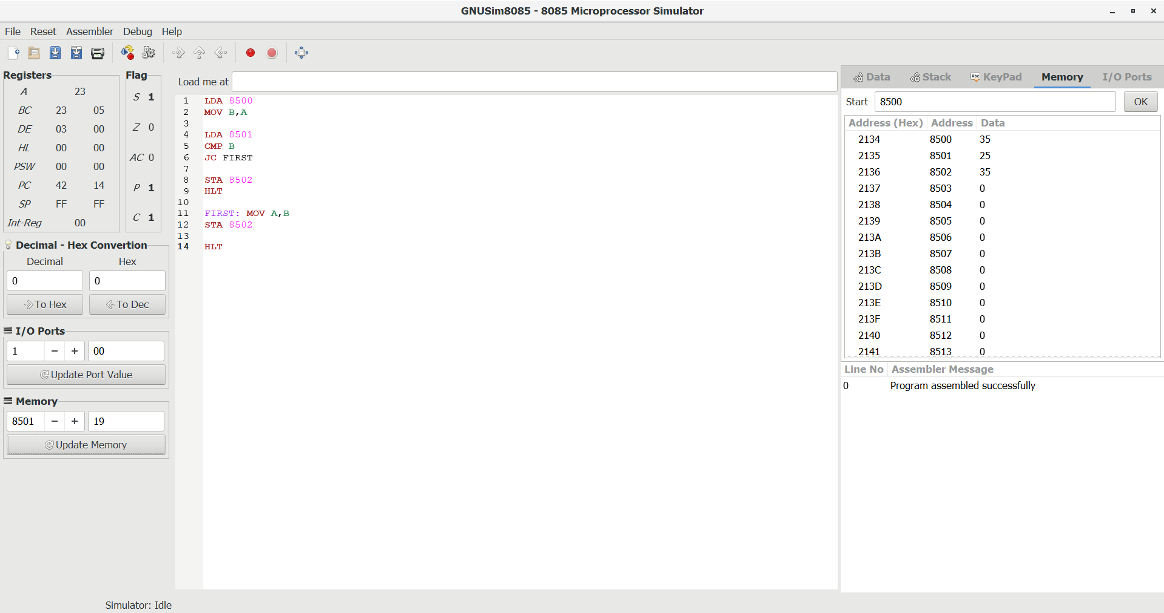
Input – 35,25
Output – 35

EXPERIMENT 8 – SMALLEST OF TWO NUMBERS

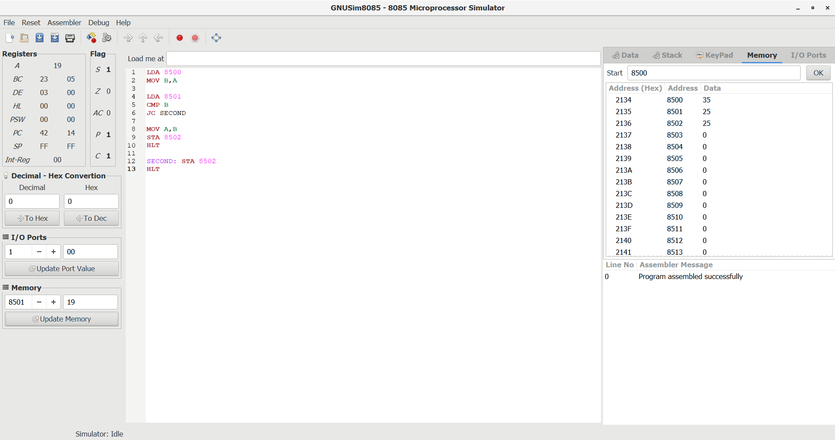
Input – 35,25
Output – 25

EXPERIMENT 9 – SWAPPING OF 2 NUMBERS

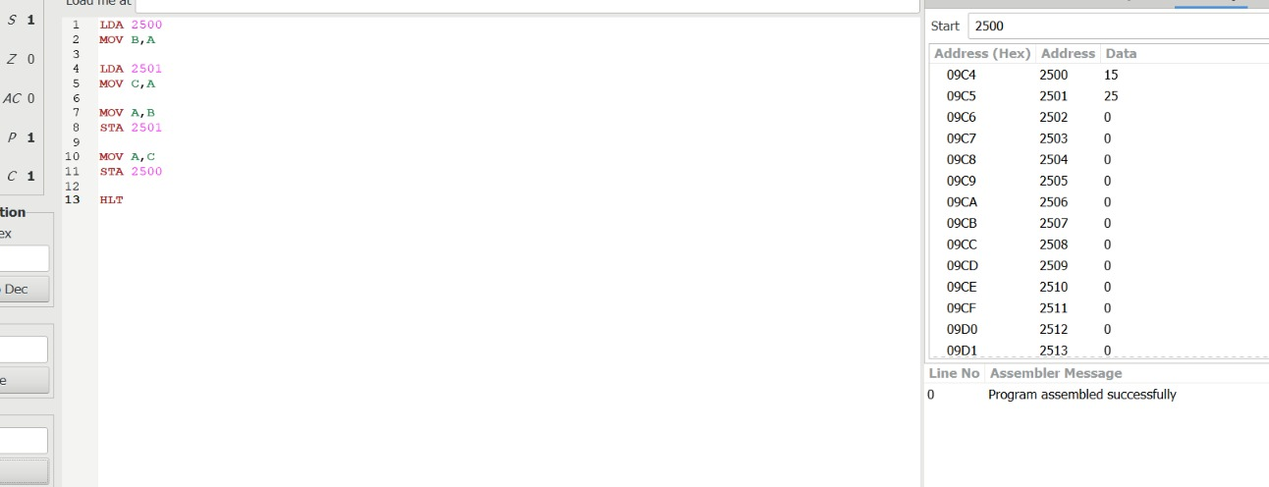
Input – 25,15
Output – 15,25

EXPERIMENT 10 – 1’S COMPLEMENT

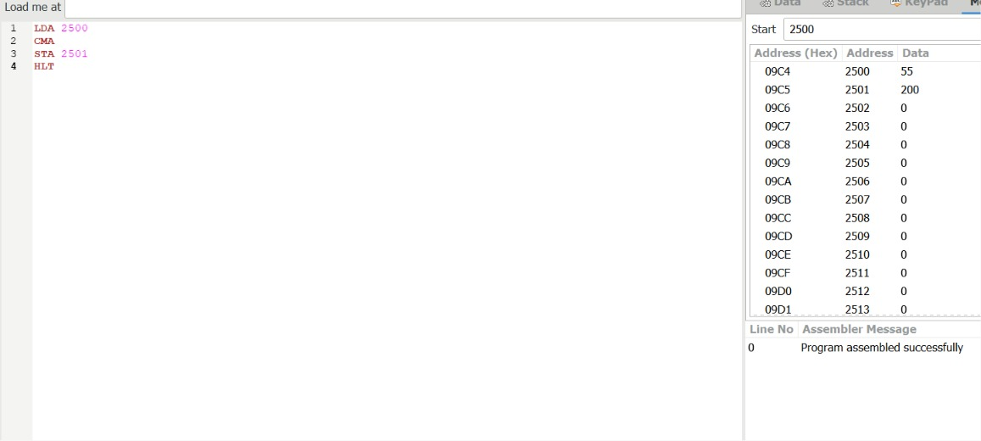

EXPERIMENT 11 – 2’S COMPLEMENT

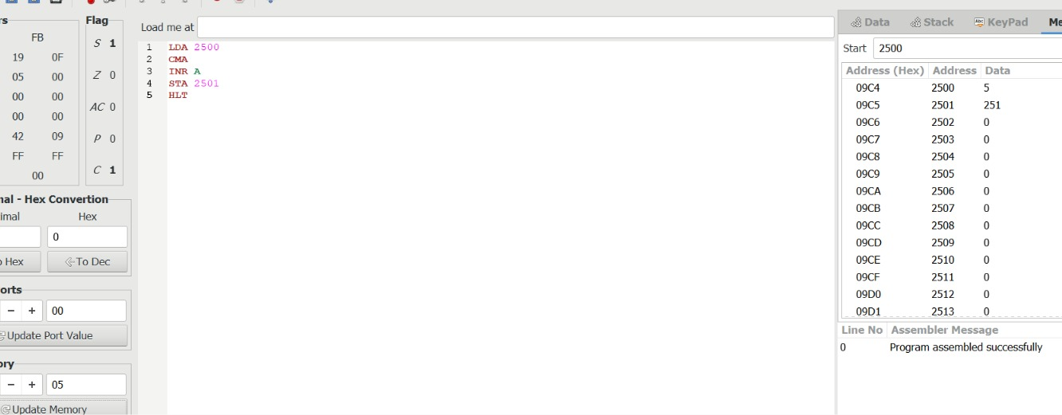

EXPERIMENT -12 FIND THE GIVEN NUMBER IS ODD OR EVEN

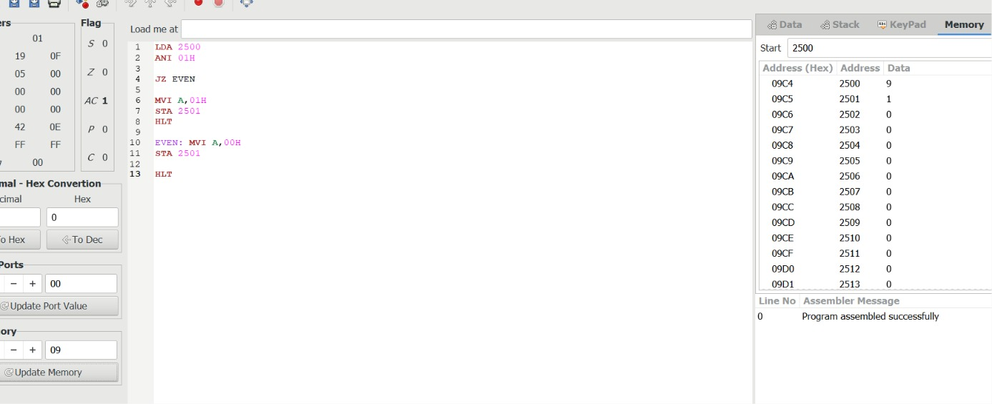
Input – 9
Output – 1

EXPERIMENT – 13 CHECK WHETHER THE NUMBER IS POSITIVE OR NEGATIVE

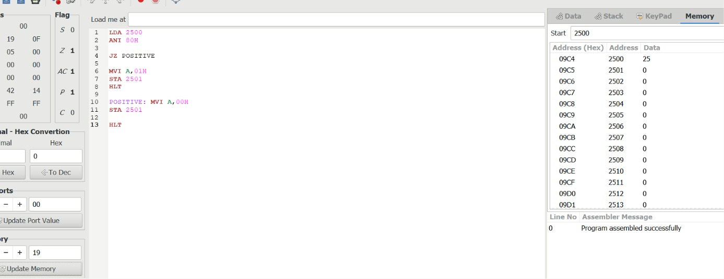
Input – 25
Output – 0

EXPERIMENT – 14 ASCENDING ORDER

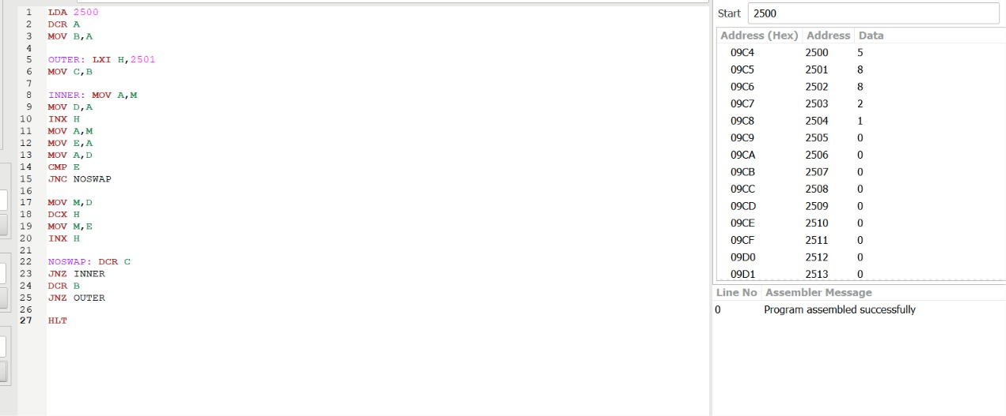
EXPERIMENT 15 - DESCENDING ORDER

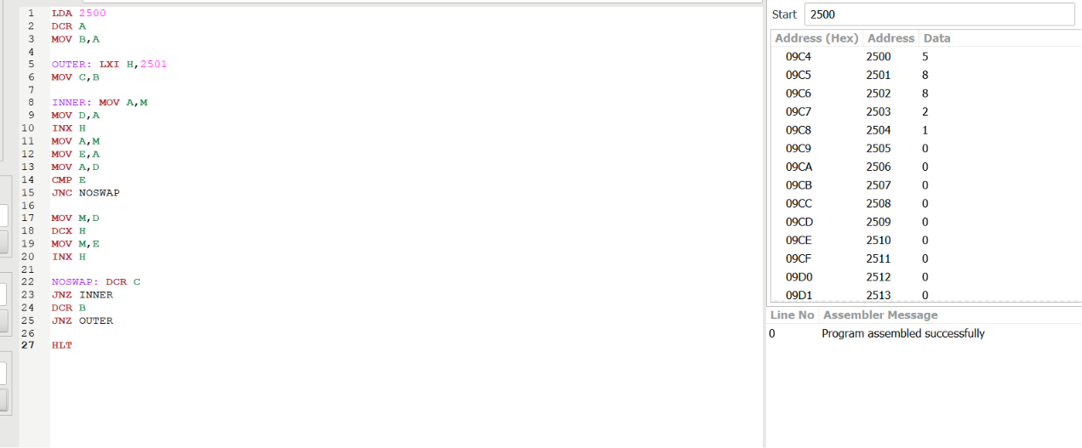

EXPERIMENT 16 – LARGEST NUMBER

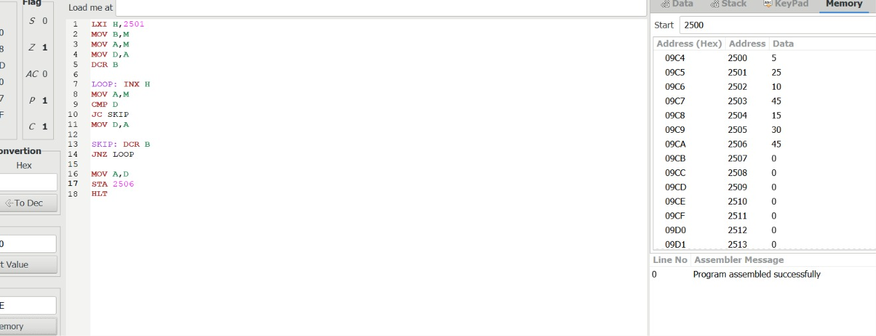

EXPERIMENT 17 – MINIMUM NUMBER

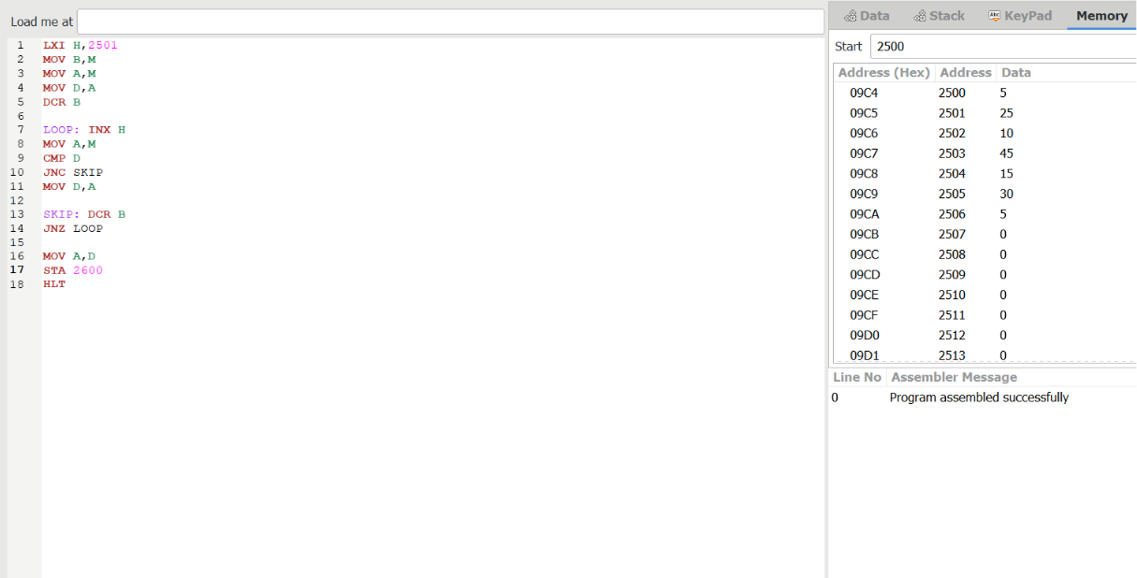

EXPERIMENT 18 LCM

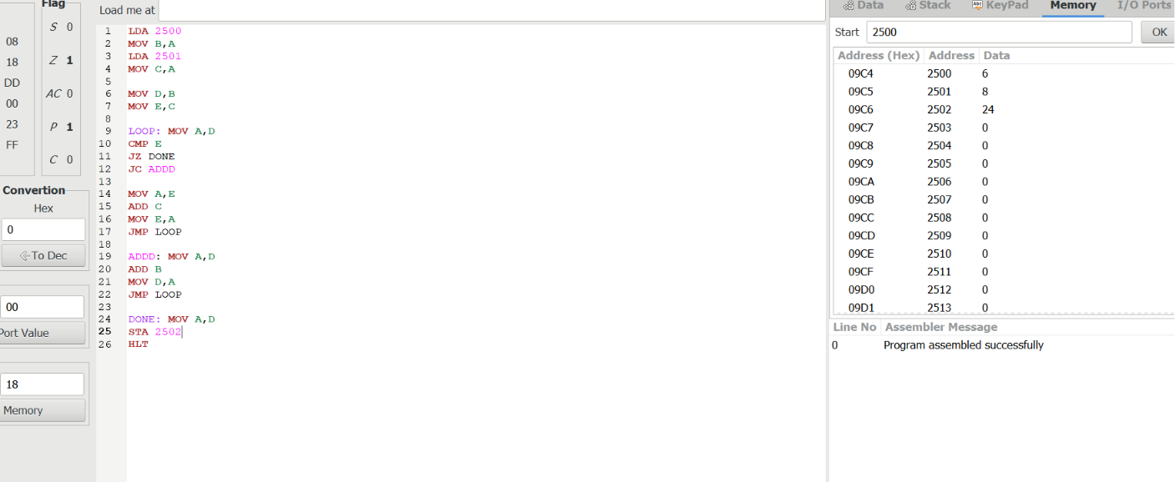

EXPERIMENT 19 – GCD

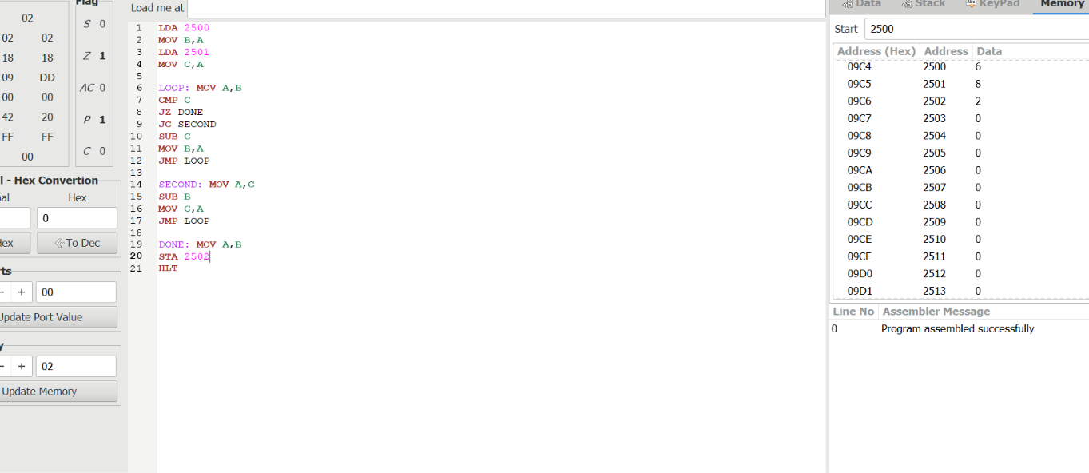

EXPERIMENT 20 – FACTORIAL

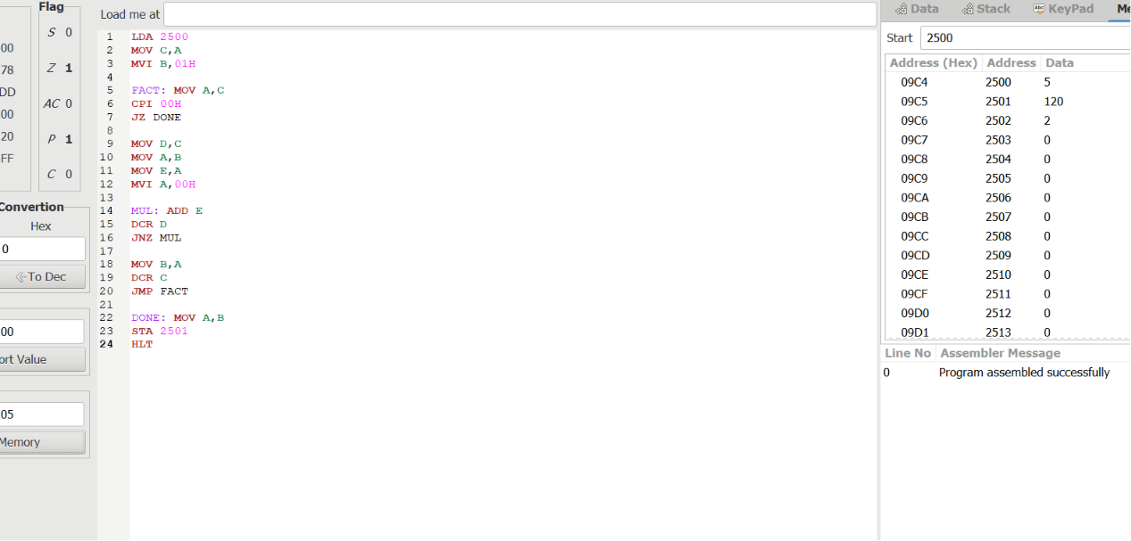

EXPERIMENT 21 – DECIMAL TO HEXADECIMAL

